Download Free Copy of Bootstrap studio using Student Pack

1. Login into github and visit dev-pack on <https://education.github.com/pack>
2. Go to “Bootstrap Studio” and Click on link to activate the offer

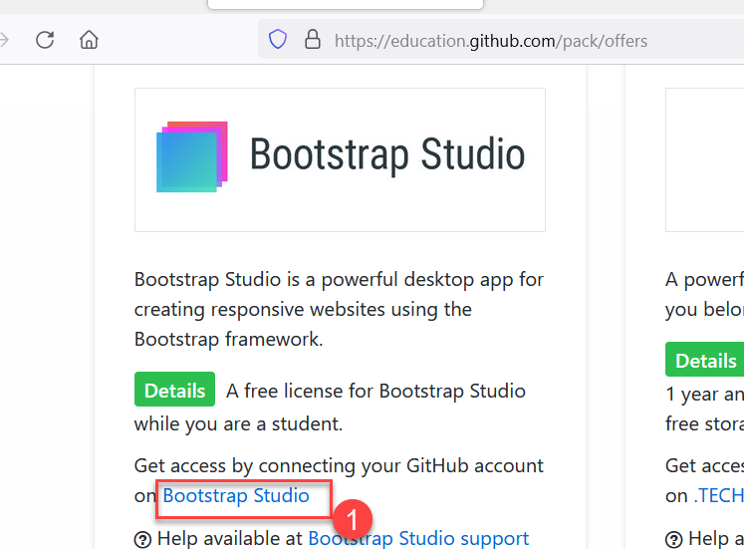

1. You should login with your email id (one used on github education)

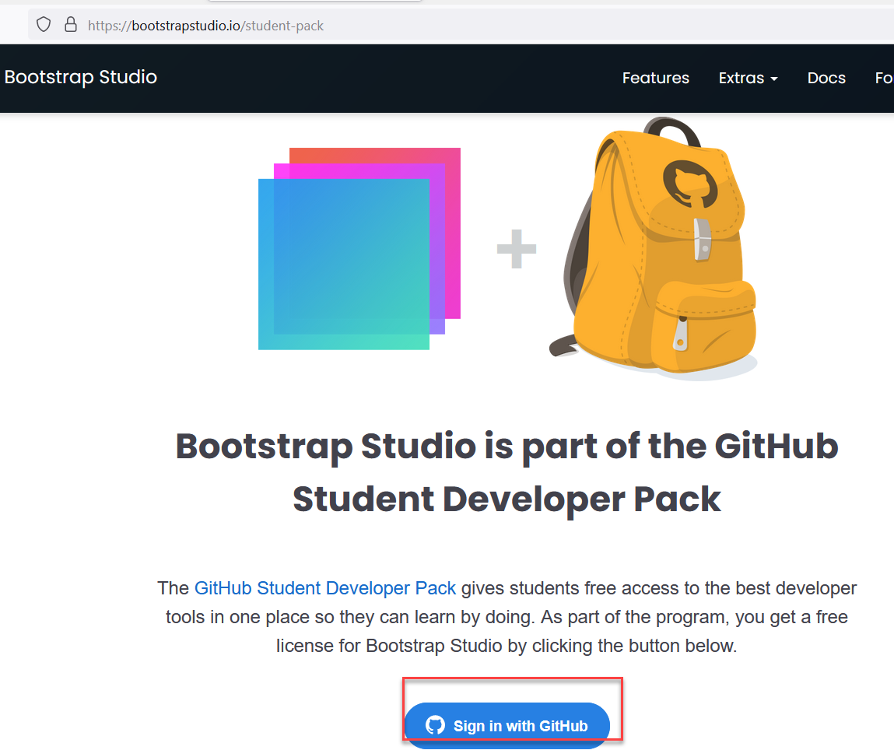

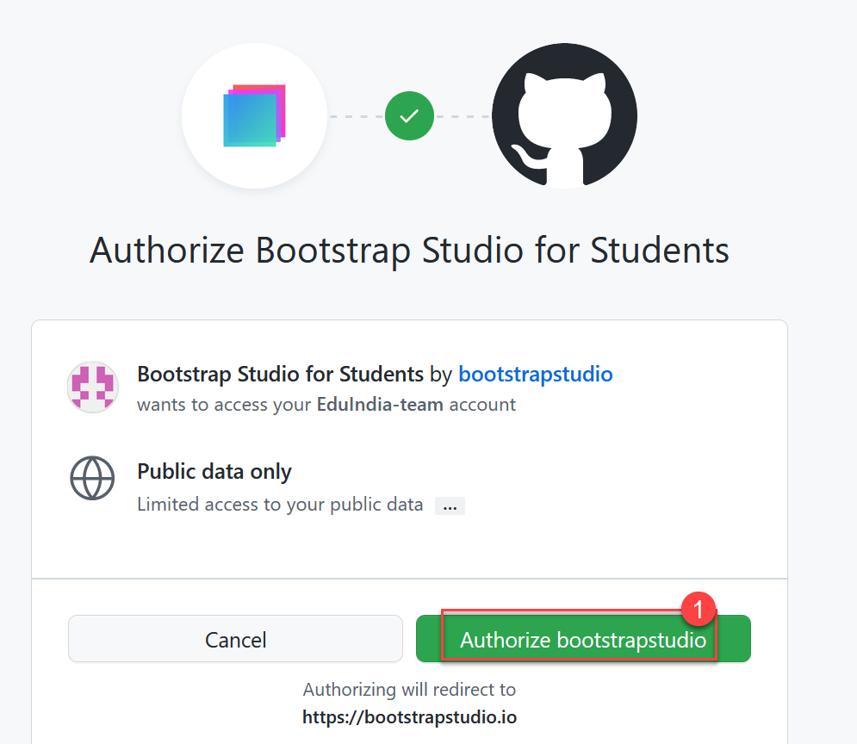

1. You should get product key and link to download. Copy product key and use link to download the setup.

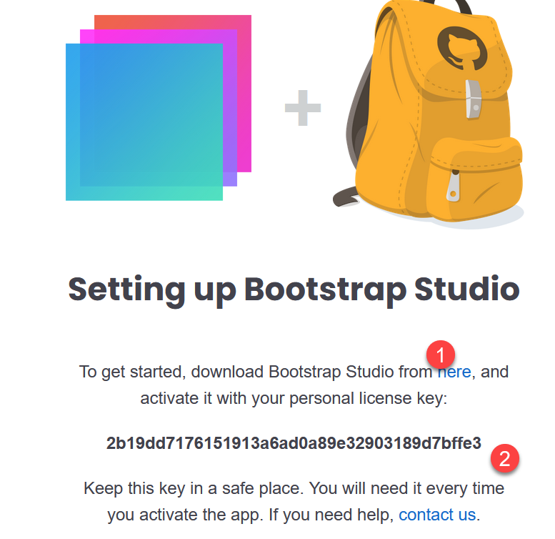

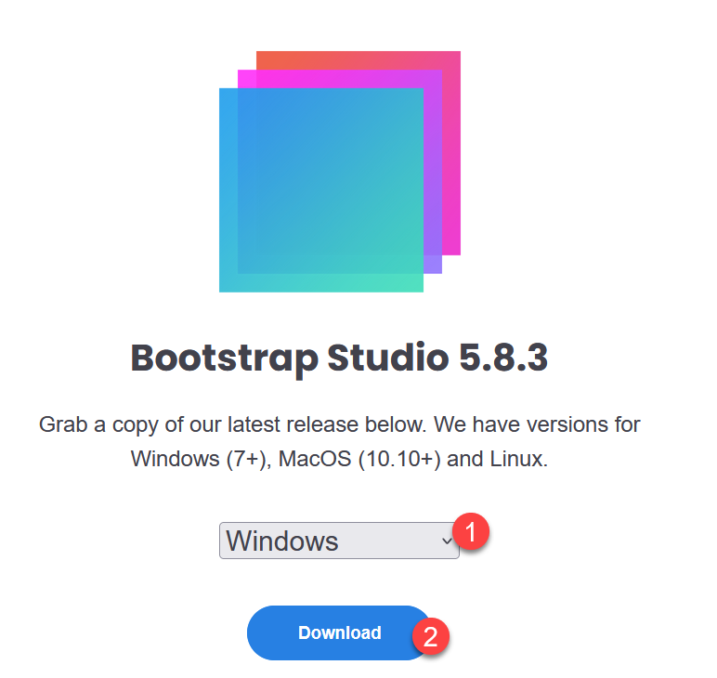

1. Once you install bootstrap, it should prompt you for product key to activate the product.

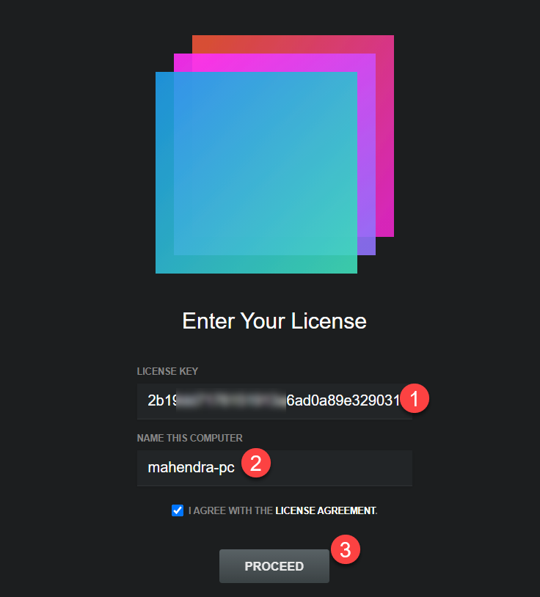

1. Now, your bootstrap studio should be ready! Now choose template to start with your website. I have used “Grayscale” for my sample web-site.

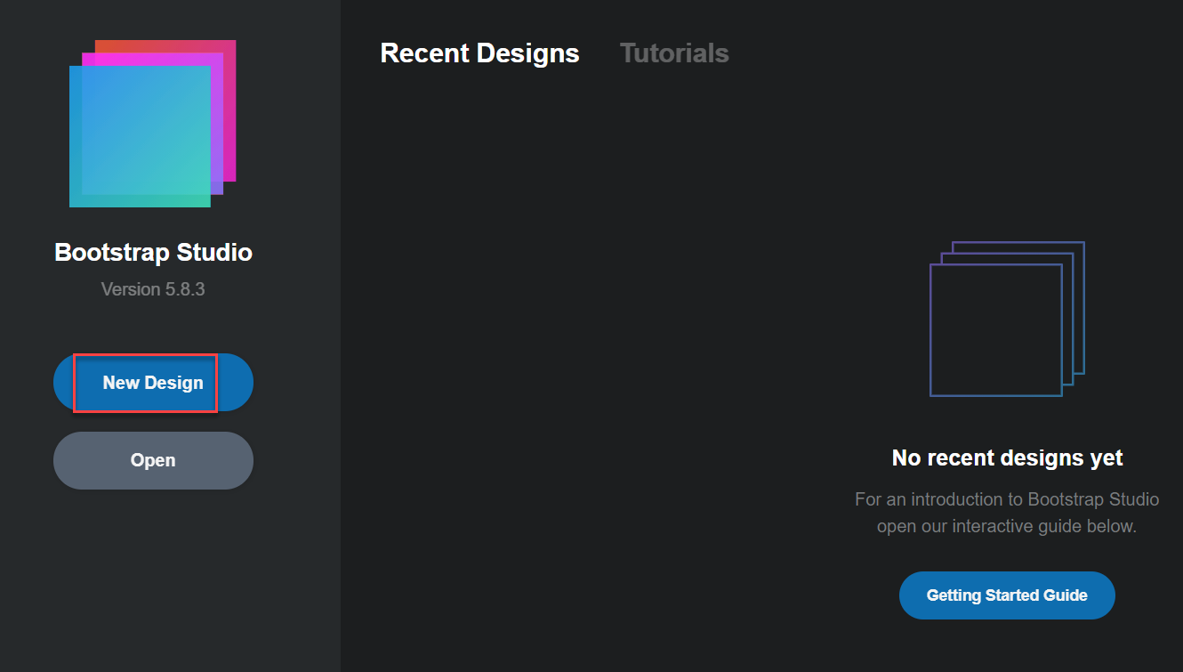

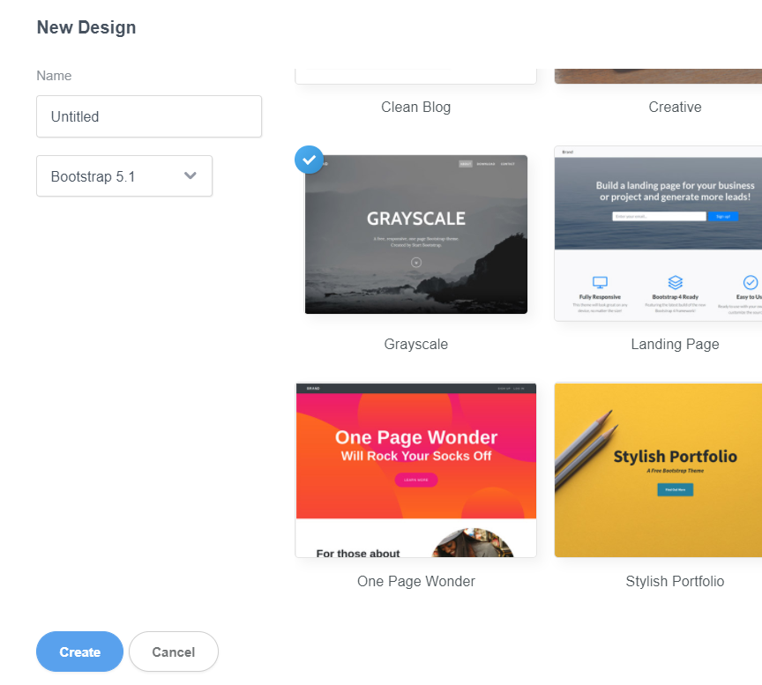

1. After your editing is complete, use export option to save the static website in folder.

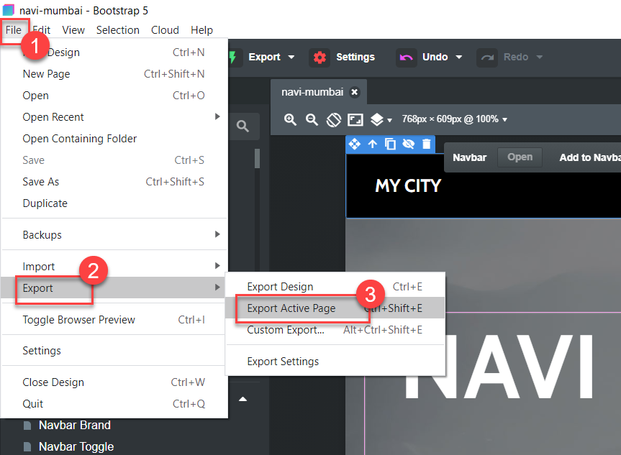

Now Make sure you select first three options (as shown in screenshot below) before export process begins:

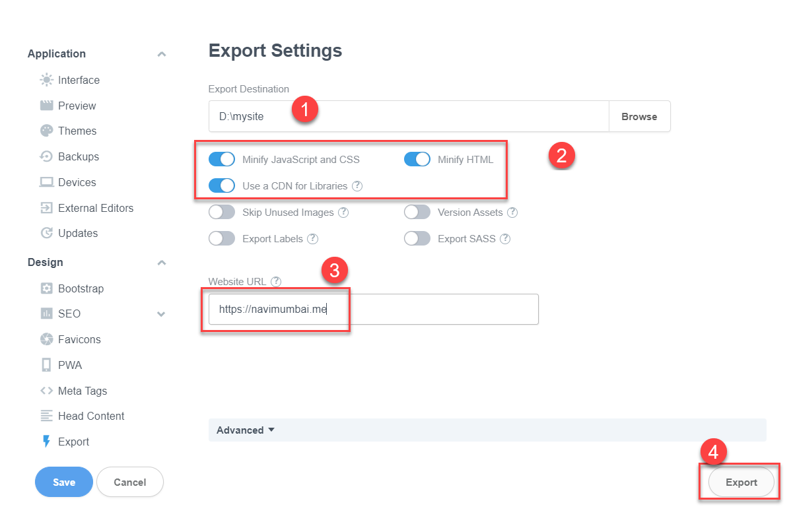

Note: I have also entered my website domain (One I have purchased from namespace.com )

1. You have check “D:\mysite” folder for the contents. You should be able to open page “index.html” in web browser to test.